**TEAM 45 ELECTRONIC DESIGN NOTEBOOK**

**DESIGN CHALLENGE 3**

**KATHRYN ATHERTON**

**JOSHUA HAHN**

**HANNAH MACKIN SCHENCK**

**OBJECTIVE:**

Develop an innovative idea using a collection of sensors and circuit elements to do something your team finds useful.

**IDEA DEVELOPMENT:**

* LED lights up when a certain knocking pattern is executed
* Vibration Sensor makes LED light up a Morse Code Message – “SOS”
* Magnetic sensor determines whether or not a door is opened or closed
* Photocell light sensor determines the brightness of the LED (automatic nightlight/phone screen)
* **Clapper light remote**

**SYSTEM DESCRIPTION:**

When someone claps three times, the vibration sensor detects this action, and turns the LED on or off, depending on its current state. The Arduino reads in input values from the vibration sensor. If these inputs are above a certain threshold (to deter random vibrations from the environment), and if there are three acceptable inputs in a row, the Arduino changes the current state of the LED – on or off.

**DESIGN SPECIFICATIONS:**

|  |  |  |  |
| --- | --- | --- | --- |
| **Customer Need** | **Technical Need** | **Technical Requirement** | **Target Value** |
| Turns on/off after 3 claps | Times out of 10 claps are detected correctly | 9/10 trials work correctly | 10/10 trials work correctly |
| Sense a variety of clap vibrations | Vibration Intensity detected | Above the threshold of 30 | Above the threshold of 30 |

**DESIGN SKETCHES:**

**Circuit Sketch:**

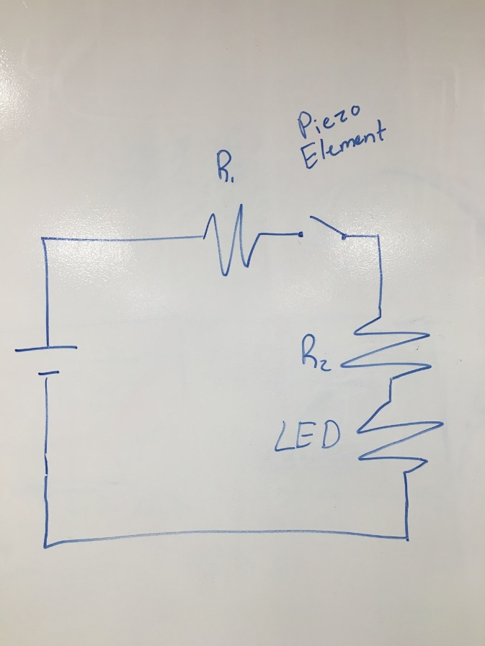

**Flowchart:**

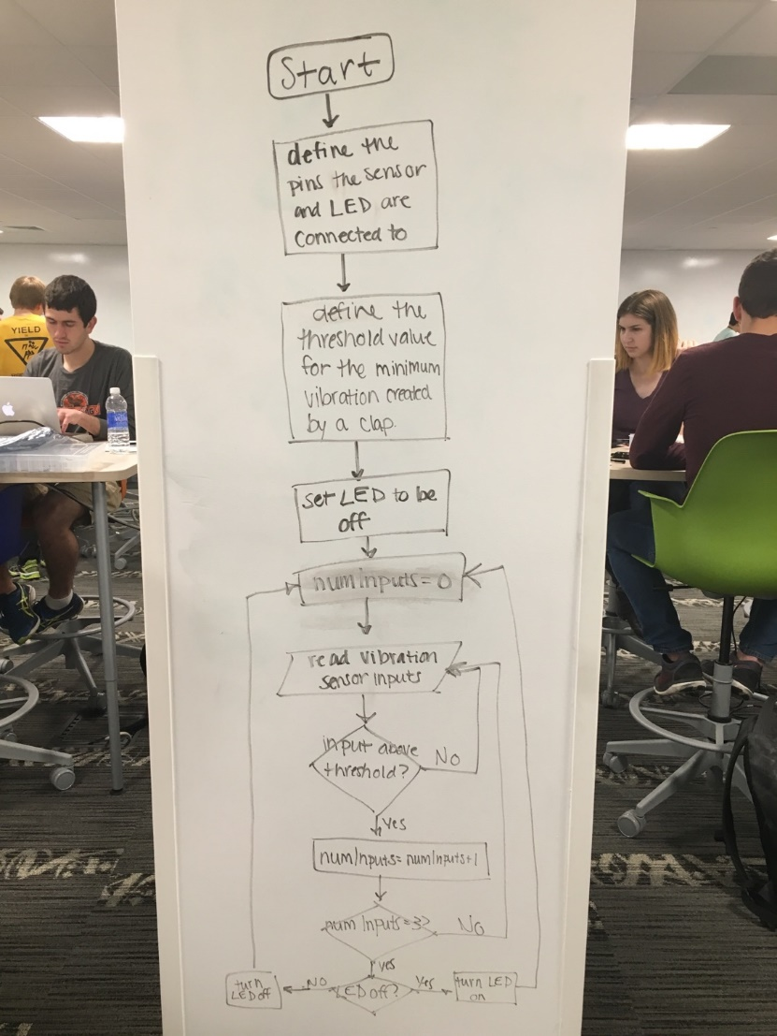

**SYSTEMS INTEGRATION:**

If this system is used in a flashlight, nightlight, or lantern, there must be a system to hold the Arduino, circuit, sensor, and light, as well as a power source, which can turn the entire system on and off when it is not in use. Containing the sensor may change the threshold required to trip the vibration sensor and turn on/off the LED light, as vibrations due to claps may be absorbed by the container. The sensor may also have to have a maximum vibration threshold, so that if the system is dropped, the vibrations due to dropping do not trip the vibration sensor to turn the LED light on or off.

If this system is used in a room, rather than a hand-held device, a container does not need to be designed, and dropping the sensor does not need to be taken into account. However, the sensor is more likely to pick up vibrations from doors, furniture, people moving around the room and causing vibrations in the walls. It would also have to be sensitive to claps/taps on the other side of the room.

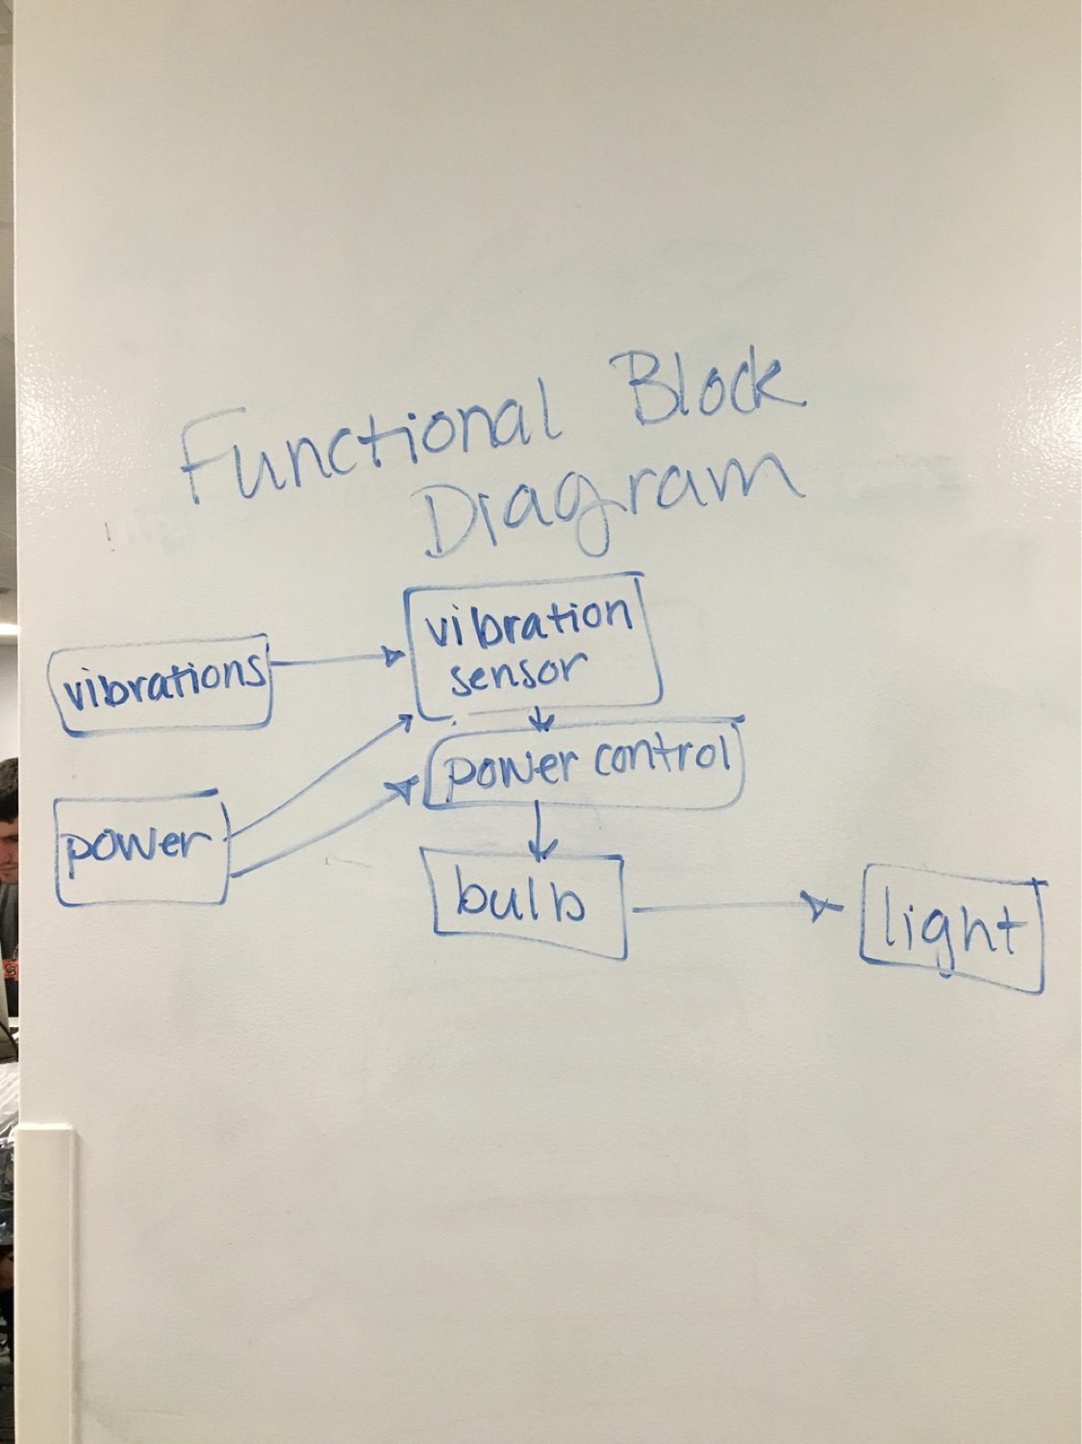

**ELECTRICAL COMPONENTS:**

The electricity flows through the circuit until the vibration sensor is reached and, when a vibration is detected, two pads in the vibration sensor complete the circuit to allow the electricity to flow through the entire circuit. Once three vibrations are detected, a switch is tripped to turn on/off the LED, and the cycle is repeated.

**TESTING:**

Testing Round 1: Threshold value = 100

Observations: The LED is turned on only if the breadboard itself is knocked, and is not sensitive to vibrations close to the breadboard occur.

Testing Round 2: Threshold value = 50

Observations: The LED is never tripped. This is due to a coding error, which contains a while loop, rather than if statements. The while loop changes the counting of the number of acceptable inputs within a certain span of time, restarting the counting every 500 milliseconds, rather than adding the to the count. Once this error was fixed, the LED was tripped when the vibration sensor is tapped lightly, but does not change the state of the LED due to a clap.

Due to these results, the design was changed to look for knocks, rather than claps, as the vibration sensor is not sensitive enough to detect clapping vibrations.

Testing Round 3: Threshold value = 5

Observations: The LED is tripped after only two taps, as it is too sensitive to the knocks. This may be due to the system waiting one second before it can be turned on/off again.

Testing Round 4: Threshold value = 30

Observations: The LED is tripped much more consistently. Although it does not detect claps, as originally planned, the system works perfectly according to the new design plan.

**DISCUSSION:**

To allow the system to work as originally planned, the vibration sensor should be set at a very low threshold, but also have a maximum threshold so as to prevent vibrations such as door slams and bumps from tripping the sensor.

Another idea to pursue would be to increase the amount of light for every tap detected with multiple LEDs. This could control the amount of light coming from the flashlight/lantern/nightlight/room/etc. depending on the amount of claps/taps detected.

**FINAL CIRCUIT DESIGN:**

